|  |
| --- |
|  |
| xTuple PostBooks Edition |
|  |
| Case Study – Part B |

Date: April 1, 2015

Authored by:

Liliya Artyukh

Rodrigo Domiciano de Almeida

Lesley-Ann Comissiong

Kathleen Wilson

Table of Contents

1.0 Overview 2

2.0 Architecture 2

Qt Framework 2

OpenRPT 3

CSVImp 3

PostgreSQL 3

Updater 3

Client Extensions 3

3.0 Activity Diagrams for xTuple PostBooks Edition 4

Creating a Sales Order 4

Time & Expense Tracking 5

Creating an Account Incident 5

4.0 Use Case for Sales Order Module 7

5.0 Main Transactions of CRM 8

Making a Sale 8

6.0 Capabilities and Benefits 12

Capabilities: 12

Benefits: 12

7.0 Customization and ERP Integration 13

Customization 13

ERP Integration 13

Technical issues on implementation 13

8.0 Additional CRM Applications 15

9.0 Bibliography 18

# Overview

xTuple PostBooks Edition is a full featured ERP solution that is fully integrated with Accounting, CRM and EFP functionality [1]. It is built to run on a local server or can be accessed through the Cloud, thereby providing businesses flexibility and scalability to meet their particular needs. The application is not platform specific as it runs equally well on Windows, Linux, Mac and mobile operating systems. It is fully internationalized for multi-currency, support for multiple tax structures and multilingual translation packs, which is maintained by the global xTuple community.

# Architecture

The application itself is built on open source technologies and uses classic client/server architecture for easy installation and maintenance. Some of the open source technologies that are used by the system are:

* C++ with the Qt framework for the client
* OpenRPT – an open source report writer that is embedded in the application
* CSVImp – a free, open source tool for importing data into a database from comma-separated text files
* the PostgreSQL database server
* Updater – a free, open source tool for upgrading databases and loading extension packages
* Extension packages written in JavaScript that are used to add new windows to the desktop

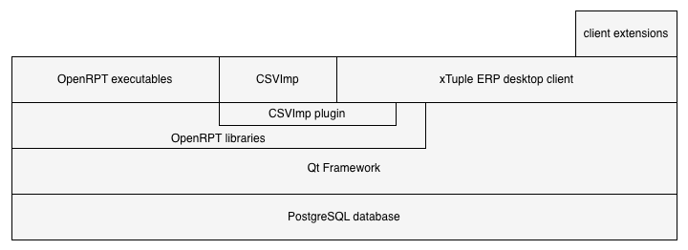

Figure 1: xTuple system architecture

## Qt Framework

The Qt is an open source application framework written in C++ and used to develop high performance multi-platform applications. The use of this framework enables the application to be built without any specific coding for the underlying operating system and it provides the use of prebuilt tools and libraries that speed up application development.

## OpenRPT

OpenRPT is the report writing and rendering utility that is embedded within the application, providing reporting design and execution through the OpenRPT compiler.

## CSVImp

xTuple has also built a data import utility, CSVImp, which also has its own open source project. It also is embedded into xTuple ERP so data can be imported directly from the application.

## PostgreSQL

xTuple uses PostgreSQL's rich and robust database architecture to store basic data structures and to process complex business logic through stored procedures, triggers, constraints, views and object inheritance.

## Updater

As development progresses on the xTuple client, the contents and structure of the supporting database change from time to time. Changes might include adding new columns to existing tables, adding new tables altogether, changing data constraints, etc. With every release of the xTuple ERP software, we provide Updater packages to make it easy for you to upgrade your existing database to work with the new desktop client. You can find the Updater project on GitHub.

Extensions

## Client Extensions

Desktop client extensions are written primarily in JavaScript, Qt user interface definition files, and OpenRPT report definitions and MetaSQL statements. Extensions can add new windows to the desktop application or modify the behavior and appearance of core windows written in C++. The reports, .ui files, MetaSQL statements, and other parts of extensions are usually stored in the database and loaded using the Updater.

# Activity Diagrams for xTuple PostBooks Edition

There are several different modules within xTuple that provides functionality for several business areas such as:

* Sales
* Manufacture
* Asset management
* CRM
* Accounting
* Purchase

For the purpose of this project, three activities have been chosen from the CRM module to detail the activities for:

1. Creating a sales order
2. Tracking time & expense
3. Creating an account incident

## Creating a Sales Order

xTuple allows users to easily create a customer sales order through the Sales Module[2]. The sales order details are captured and product availability can be viewed. If a product is not available from inventory, the user can create a work order to request product to be manufactured so that the order can be fulfilled. The user is also able to apply customer discounts to the order so that it is automatically applied to the invoicing process when the customer is being billed.

Figure 2: Activity diagram for creating a sales order

## Time & Expense Tracking

The CRM module in xTuple allows for the tracking of time and expenses [3]. Employee and contractor expenses can be captured to enable labor and material costs to be applied to the relevant projects. It also enables expenses to be billed to a customer account or project and monies reimbursed to employees and contractors for expenses incurred.

Figure 3: Activity diagram for creating a time and expense sheet

## Creating an Account Incident

The Incident Workbench within the CRM module enables the user to monitor and record Incidents that are linked to Accounts, Contacts, Users, and To-Do’s [4]. The flexibility offered by the Incident Workbench enables the effective management of different business processes such as customer requests or issues, vendor certification, inbound/outbound component and product quality tests and any other processes that require tracking.

Figure 4: Creating an Account Incident

The three activities shown in figures 2, 3 and 4, demonstrate how xTuple automatically creates linkages to multiple cross-departmental functions within the organization. This allows for timely, reliable and accurate data being available to persons who use this information. Automated tracking and reminders enable employees to be more efficient and gives a holistic view of a Customer, Account or Project.

# Use Case for Sales Order Module

The following Use Case diagram represents six of the main functions of xTuple’s Sales module. The CRM user will be able to setup customers, create sales orders, create quotes, add prices, lookup quotes and items, and perform billing operations.



Figure 5: Sales modules Use Case diagram

# Main Transactions of CRM

There are many main transactions in xTuple. Two of the main transactions will be demonstrated in this section, which extends off of section 3.0 above. The first transaction, is making a sale, and the second transaction is incident management.

## Making a Sale

#### The Scenario: Business-to-Business

Tom is a CRM representative for ABCShoes Inc. He receives an email from Sara (a prospective customer from ShoeStore Inc.) about ordering a wholesale batch of shoes. After speaking with Sara, Sara decides that she wants to order shoes from Tom. Sara creates an order on ABCShoes Inc.’s website.

The process of making a Business-to-Business sale in xTuple is as follows:

#### View the sales order: Sales > Sales Order > List Open

#### Issue to Shipping

Tom navigates to the “Issue to Shipping” link to set the order to the Issue to Shipping status. He must issue the quantity to shipping before shipping the order. In the image, there are no line items. In Sara’s scenario, the selected shoes would be displayed in the empty box.

1. Tom clicks the magnifying glass in the “Order #” box, then “Select List”. A list of orders appears. Tom selects the one from Sara. He clicks “Issue All”, then “Ship”.

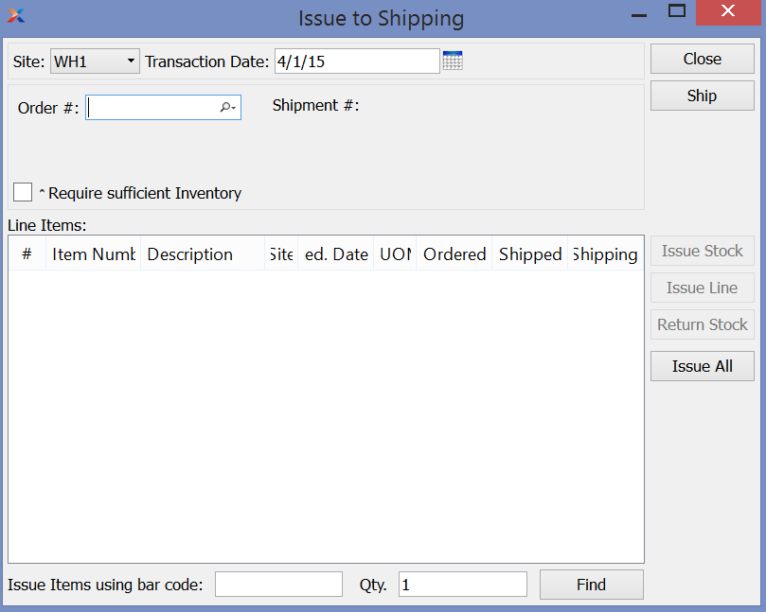

1. 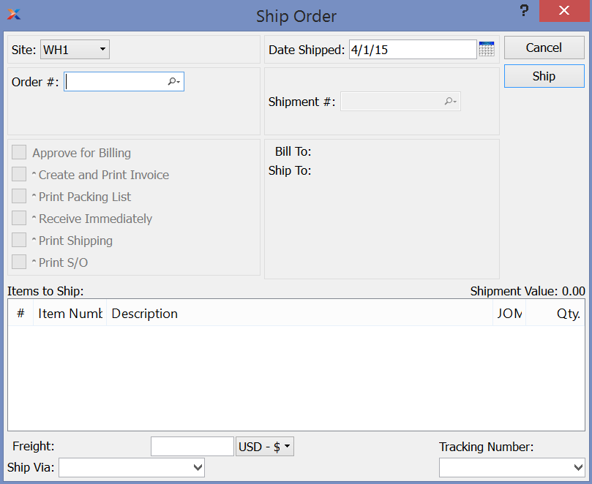A new window will appear. In Sara’s scenario, shoes are displayed in the box. He selects “Approve for Billing” and clicks “Ship”.
2. Tom prints the generated invoice (WebPortalDemoGuide)

## Create Incidents

#### The Scenario:

Sara has a quantity problem with her order. One of the shoes she received has two right feet. Sara sends an email to Tom and he registers an incident in xTuple.

#### View Incidents: CRM 🡪 Incidents 🡪 List Incidents

#### Create new incident

Tom creates a new incident for Sara’s issue. As referred to the activity diagram in section 3.0, the fields for the incident are filled out.

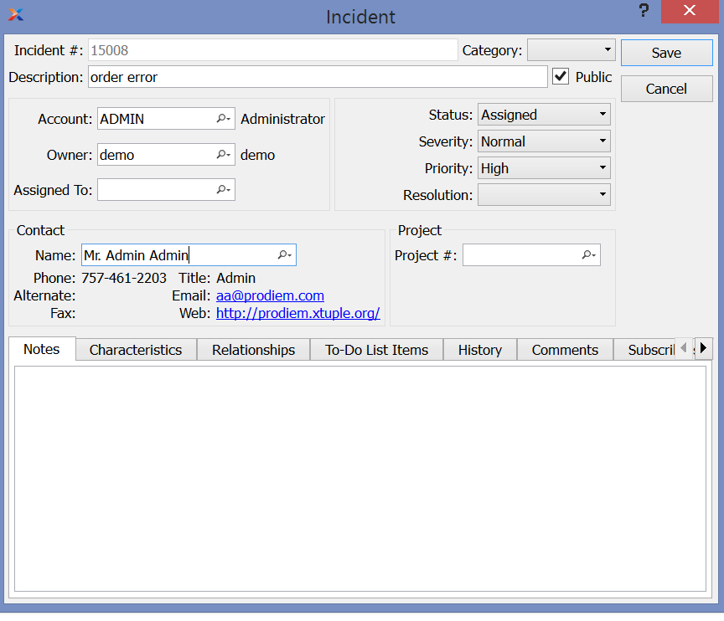

#### Send incident

Tom enters an email address to send the incident to the incident representative.

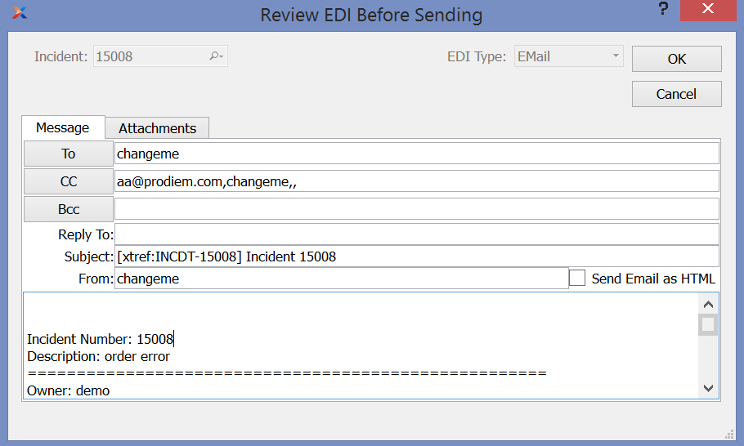

#### View Incident

The incident is displayed in the incident window.

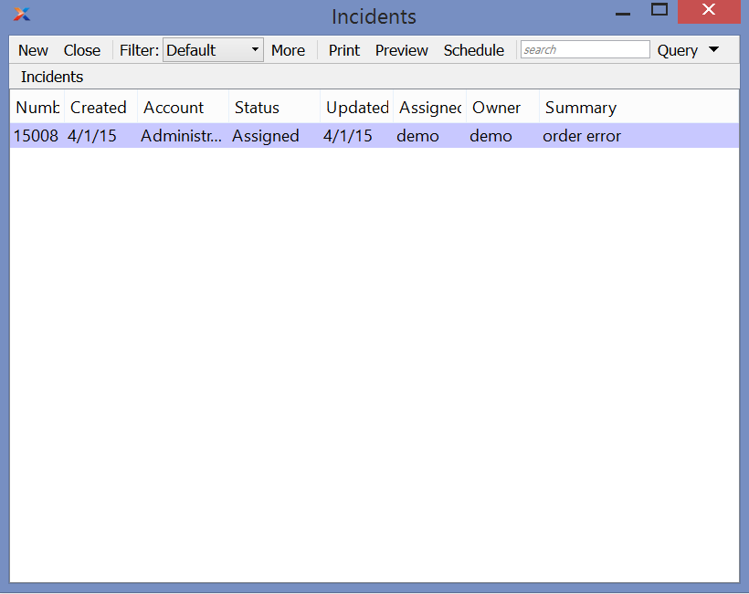

# Capabilities and Benefits

The main capabilities and benefits for the CRM of xTuple are as follows:

## Capabilities:

* Collection of various data: personal information, complaints, to do list, etc…
* Reporting to help sales representative to understand data and build strategy
* Create personalized marketing
* Cloud Portability
* Strong Flexibility - highly configurable

## Benefits:

* Convenient – everything in one place, also it is available online
* Saves time – reporting organizes data in different ways, automated emails
* Sales improvements – getting more customers, customizing communication
* Customer satisfaction – the more the company knows about the customer the better it can serve that customer

# Customization and ERP Integration

## Customization

As an open source solution, xTuple allows customers to personalize the application as they want. Training classes, online videos, development extensions and documentation are examples of resources that help the community involved to add or extend functionalities in their applications. Developers are able to design a new screen or even generate custom commands and reports.

There are basically two forms to do the customization:

* **Custom development by the source code available on SourceForge**: This option requires understanding of the source code application and extension tools provided by the company.
* **Assisted by xTuple’s Developer Team**: In this option, the customer submits a proposal of enhancement or modification to the xTuple team, which is high-skilled on the ERP and will analyze if it is possible to implement it for the customer and the base xTuple package as well. In case of being a business specific proposal which is not applicable for the base package, the customer can pay for XTN (xTuple Network) services. They guarantee safe upgrades with older versions of database and customizations previously implemented.

## ERP Integration

XTuple ERP is supported by Windows, Linux and Mac because it uses open source technologies, so one binary source code is installed quickly on any of these operating systems. There is also a mobile web client that uses HTML5, which means that it can be accessed on any browser that supports it.

The CRM solution does not have integration with social media plugins or office applications, but the marketplace offers extensions with additional features related to functional areas.

A paid extension (Connect) helps managing reports and incidents from xTuple to outside systems and vice-versa by batch jobs.

## Technical issues on implementation

In case of using the cloud application, the procedures are simple. It is just needed to download and extract the zip file which contains the GUI client for connection to the server and then type the access information. On the other hand, a stack should be matched in order to install the on premise solution. The application consists basically of a GUI client and a PostgreSQL database, so it is likely to have knowledge configuring and managing this database for xTuple. Also, both ways relies on a secure connection established between client and server; if there is a problem on this communication channel probably the user will not be able to send information through the ERP instances.

The CRM module has an interface basically made of field names and values, which makes it straightforward to set up. Few menus present the registered information on categories such as projects, contacts and sales orders.

# Additional CRM Applications

There are many CRM applications on the market. The ones that are discussed below are popular in the market and are major competitors to xTuple.

1. Salesforce.com

One of the CRM sales and marketing leaders, it offers cloud-based solutions. The products are categorized on sales, service (intelligent agents for customer support), marketing, community (integration of partners, customers and employees through a communication channel) and analytics. Additional B2B and small business solutions are provided as well.

The company has a platform for app development of its products. It allows developers (employees or even customers) to create any personalized app and exchange it on the marketplace. The information is integrated through the products and can be accessed through apps on mobile devices.

Pricing for products ranges according to the category of user: group, professional, enterprise or unlimited. Some solutions have another category names, but they are generally divided into three: standard, pro and business. All licenses are billed annually and require an annual contract as well.

"Cloud Apps and Platform - Salesforce.com Canada." *Salesforce.com*. Salesforce, n.d. Web. 30 Mar. 2015. <http://www.salesforce.com/ca/products/>.

"Salesforce." *Reviews of : Free Pricing & Demos : Customer Relationship Management Software*. Capterra, n.d. Web. 30 Mar. 2015. <http://www.capterra.com/customer-relationship-management-software/spotlight/61368/Salesforce/Salesforce%20com>.

1. Microsoft Dynamics CRM

Software package that takes part of Microsoft business solutions line. Focused mainly on Sales, Marketing and Customer Service. The application runs on the browser or by an Outlook plugin, allowing synchronization with Exchange as well. Mobile version supports Windows 8, iPad and Android tablets.

For Customer Service, there are solutions such as case management prioritized by KPI and Social Listening, which enables monitoring of products, brands and campaigns based on media channels like Facebook or Twitter. Another basic features for S&M are campaign management, process automation and product families.

Pricing is defined selecting one of four functional areas (Sales, Service, Marketing or Social) and the type of license (Professional or Enterprise). The final price depends on how many months and users will be using it.

"Win and Retain Customers." *Microsoft Dynamics*. Microsoft, n.d. Web. 30 Mar. 2015. <http://www.microsoft.com/en-us/dynamics/crm.aspx>.

"Browser Compatibility with Microsoft Dynamics CRM 2011." *Browser Compatibility with Microsoft Dynamics CRM 2011*. Microsoft, 20 Nov. 2014. Web. 30 Mar. 2015. <http://support.microsoft.com/en-ca/kb/2784954>.

*Microsoft Dynamics CRM 2015 Release Preview Guide*. N.p.: Microsoft, Sept. 2014. PDF.

1. Zoho

Suite that fits mainly Sales and Marketing of small business. Contains a salesforce automation software which has features for customer lifecycle management. Contacts, leads and campaigns are examples managed by some functions.

A Developer API is available for individuals, enabling to develop applications as well. Custom add-ons can be created for integration with Zoho Apps or third-party applications such as Office and Facebook.

For mobile, there are two features: CRM On-the-go, which provides information tracking of customers either by Apple or Android devices and CRM for Google Apps, which integrates Google Docs and Gmail services with Zoho.

There is a free license (up to 10 users) and standard, professional, enterprise and CRM plus categories. Latter ones are pay-as-you-go, being billed month-to-month or annually.

"Close More Deals in Less Time." *CRM Software, Customer Relationship Management*. Zoho, n.d. Web. 30 Mar. 2015.

1. SugarCRM

Mostly focused on user experience, uses its private interface to let the customer design the dashboard as he or she wants, using drag and drop, for example. Along common CRM features (Sales, Marketing, Workflows and Reporting), it also supports integration with Google Apps, Microsoft Office, Facebook, Twitter, IBM Notes and many others platforms. The product is hosted on cloud.

Nowadays the licenses are Professional, Enterprise and Ultimate. They differ from some features and storage space. All of them need a minimum annual subscription. Another version, a no longer upgraded Community Edition, is free and supported by the developer’s community.

There is a marketplace where users can purchase and download add-ons created by developers. In case of the Community edition, add-ons are provided only by a GitHub repository.

"CRM Software Package." CRM Software Packages and Pricing. SugarCRM, n.d. Web. 30 Mar. 2015.

https://sugarcrm-online.s3.amazonaws.com/products/datasheets/editions-comparison-chart.pdf

"Sugar Community Edition Add-ons." *Sugar Community Edition Add-ons*. SugarCRM, n.d. Web. 30 Mar. 2015.

"SugarExchange: Welcome." *SugarExchange: Welcome*. SugarCRM, n.d. Web. 30 Mar. 2015.

1. Maximizer CRM

Has a simple user interface that integrates business systems with CRM functional areas. It can be deployed on the user’s cloud or on Maximizer’s cloud. If it is deployed on-premise a few Microsoft’s features including MS SharePoint or SQL Server may be also added. All editions allow access by smartphones or tablets.

There are two types of licenses: one for Maximizer CRM and a Wealth CRM, which has additional features for the wealth management industry. Both are billed annually and they have limits for storage in case of a cloud option. Otherwise is up to the client.

"Access Anywhere, On Any Device." *All-In-One CRM*. Maximizer CRM, n.d. Web. 30 Mar. 2015.

*Maximizer CRM Feature Comparison*. Vancouver, BC: Maximizer CRM, 2014. PDF.

Shipley, Renee. "Maximizer CRM Review 2015 | Contact Manager." *TopTenREVIEWS*. Top Ten Reviews, 17 Oct. 2014. Web. 30 Mar. 2015. <http://crm-software-review.toptenreviews.com/maximizer-crm-review.html>.

# Bibliography

Moskowitz, Gil. "XTuple ERP Desktop Client Architecture." XTuple.org, 27 July 2014. Web. 25 Mar. 2015. https://github.com/xtuple/qt-client/wiki/xTuple-ERP-Desktop-Client-Architecture-Overview.

"xTuple for Inventory Businesses: Order-to-Cash and Advanced Manufacturing and Distribution." *Sales Orders*. XTuple.org. Web. 24 Mar. 2015. http://www.xtuple.org/sites/default/files/prodguide/Inventory-HTML/ch01s02.html.

"Managing Projects with XTuple." Time & Expense. XTuple.org. Web. 24 Mar. 2015. http://www.xtuple.org/sites/default/files/topics/timeexpense/index.html.

"CRM Basics." XTuple.org. Web. 29 Mar. 2015. https://www.xtuple.org/CrmBasics.

"How Do I Set up PostgreSQL and Install PostBooks®? | XTuple." *How Do I Set up PostgreSQL and Install PostBooks®? | XTuple*. XTuple, n.d. Web. 30 Mar. 2015. <http://www.xtuple.com/installing-postbooks-database>.

"XTuple Connect Product Guide." 1. What Is XTuple Connect? XTuple, n.d. Web. 30 Mar. 2015. <http://www.xtuple.org/sites/default/files/prodguide/connect/pr01s01.html>.

"How Do I Set up PostgreSQL and Install PostBooks®? | XTuple." *How Do I Set up PostgreSQL and Install PostBooks®? | XTuple*. XTuple, n.d. Web. 30 Mar. 2015. <http://www.xtuple.com/installing-postbooks-database>.

"Cloud Apps and Platform - Salesforce.com Canada." *Salesforce.com*. Salesforce, n.d. Web. 30 Mar. 2015. <http://www.salesforce.com/ca/products/>.

"Salesforce." *Reviews of : Free Pricing & Demos : Customer Relationship Management Software*. Capterra, n.d. Web. 30 Mar. 2015. <http://www.capterra.com/customer-relationship-management-software/spotlight/61368/Salesforce/Salesforce%20com>.

"Win and Retain Customers." *Microsoft Dynamics*. Microsoft, n.d. Web. 30 Mar. 2015. <http://www.microsoft.com/en-us/dynamics/crm.aspx>.

"Browser Compatibility with Microsoft Dynamics CRM 2011." *Browser Compatibility with Microsoft Dynamics CRM 2011*. Microsoft, 20 Nov. 2014. Web. 30 Mar. 2015. <http://support.microsoft.com/en-ca/kb/2784954>.

*Microsoft Dynamics CRM 2015 Release Preview Guide*. N.p.: Microsoft, Sept. 2014. PDF.

"Close More Deals in Less Time." *CRM Software, Customer Relationship Management*. Zoho, n.d. Web. 30 Mar. 2015.

"CRM Software Package." CRM Software Packages and Pricing. SugarCRM, n.d. Web. 30 Mar. 2015.

https://sugarcrm-online.s3.amazonaws.com/products/datasheets/editions-comparison-chart.pdf

"Sugar Community Edition Add-ons." *Sugar Community Edition Add-ons*. SugarCRM, n.d. Web. 30 Mar. 2015.

"SugarExchange: Welcome." *SugarExchange: Welcome*. SugarCRM, n.d. Web. 30 Mar. 2015.

"Access Anywhere, On Any Device." *All-In-One CRM*. Maximizer CRM, n.d. Web. 30 Mar. 2015.

*Maximizer CRM Feature Comparison*. Vancouver, BC: Maximizer CRM, 2014. PDF.

Shipley, Renee. "Maximizer CRM Review 2015 | Contact Manager." *TopTenREVIEWS*. Top Ten Reviews, 17 Oct. 2014. Web. 30 Mar. 2015. <http://crm-software-review.toptenreviews.com/maximizer-crm-review.html>.